**RISHI BANKIM CHANDRA EVENENG COLLEGE**

**NAIHATI, WEST BENGAL**



Date :- 08-08-2024

**Notice**

In accordance with the G.O. no. 3551--F(P-2), dated, Howrah, the 8th August '24, the College will remain closed to-day (8th August '24) due to sad demise of our Ex -- Chief Minister **Buddhadeb Bhattacharyya**.

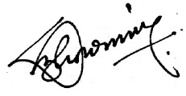

Principal

Rishi Bankim Chandra Evening College